[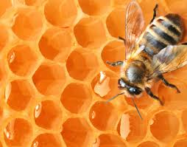](http://www.google.nl/url?sa=i&rct=j&q=&esrc=s&source=images&cd=&cad=rja&uact=8&docid=eRD_rF3OMtnoqM&tbnid=glHuuKBx9Q04lM:&ved=0CAUQjRw&url=http://www.jappie.eu/muurstickers-dieren-wildernis-muurprint-honing-drieluik-p-17615.html&ei=TuT1U8zlNYLfOYLpgbAP&bvm=bv.73231344,d.ZWU&psig=AFQjCNFv_mvWtxzvKu_0idUaWgKE5u2Ccw&ust=1408710075853952)

[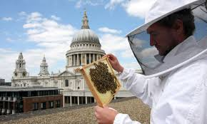](http://www.google.nl/url?sa=i&rct=j&q=&esrc=s&source=images&cd=&cad=rja&uact=8&docid=iecQdxxc_DV4-M&tbnid=t27_yhLctFrvIM:&ved=0CAUQjRw&url=http://www.theguardian.com/environment/2010/aug/17/bees-urban-pollen-diet&ei=w-T1U4eIN4noOtLsgcgF&bvm=bv.73231344,d.ZWU&psig=AFQjCNGqIXGdLFZs9uouqtIrGi56kX0eIQ&ust=1408710155662498)