[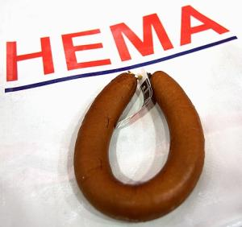](http://www.google.nl/url?sa=i&rct=j&q=hema%20rookworst&source=images&cd=&cad=rja&docid=1DJmaapBJRE8CM&tbnid=kSNk9m34TffU2M:&ved=0CAUQjRw&url=http://wp.digischool.nl/duits/oefenen/land-en-mensen/duitsland-abc/eten-en-drinken/&ei=3VwfUuXyMOHI0wXX8YD4Ag&bvm=bv.51495398,d.d2k&psig=AFQjCNEvLdexmzU-HLn_-OTm8AvnU7na9g&ust=1377873478755757)

[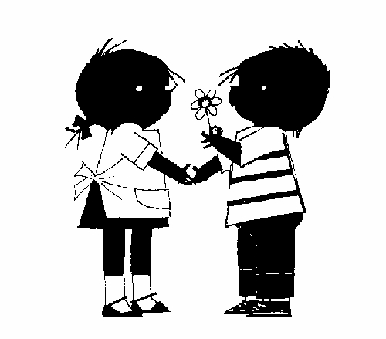](http://www.google.nl/url?sa=i&rct=j&q=jip+en+janneke&source=images&cd=&cad=rja&docid=VUYwavi-fz_jrM&tbnid=BVCZ958t6YzrBM:&ved=0CAUQjRw&url=http://www.abc.nl/blog/?tag=jip-janneke&ei=Wl8fUor-N4aG0AXy7YEY&bvm=bv.51495398,d.d2k&psig=AFQjCNFeAKoDcpHw_mmWDPhTu-wWY7fTiQ&ust=1377874097122400)

