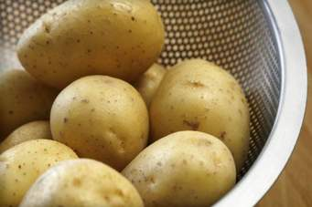

[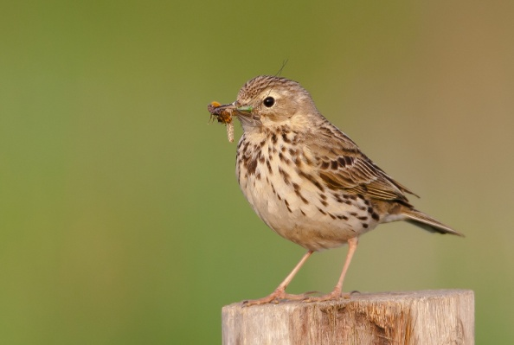](http://www.google.nl/url?sa=i&rct=j&q=&esrc=s&source=images&cd=&cad=rja&uact=8&ved=0CAcQjRxqFQoTCID8pqufnscCFcq1FAod8F8AcA&url=http://www.natgeofoto.nl/foto/graspieper-18&ei=nXTIVcC5JMrrUvC_gYAH&bvm=bv.99804247,d.d24&psig=AFQjCNGllcrHc-OQTZTnjs44JZQjqPm5bQ&ust=1439286766641751)