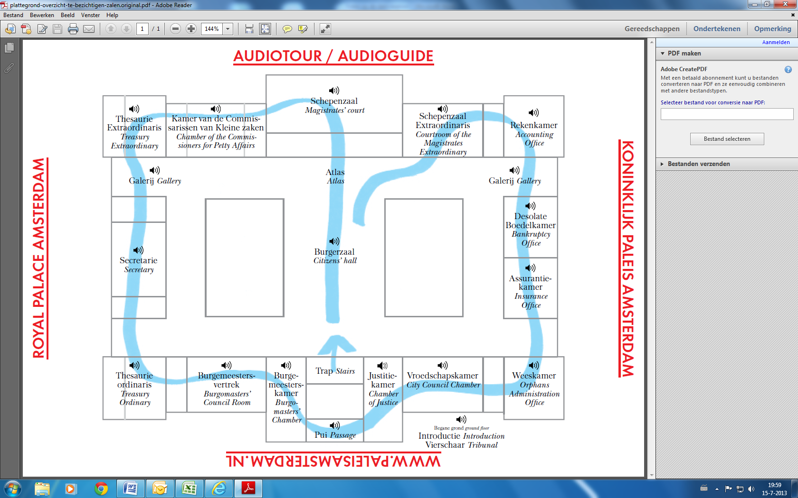

[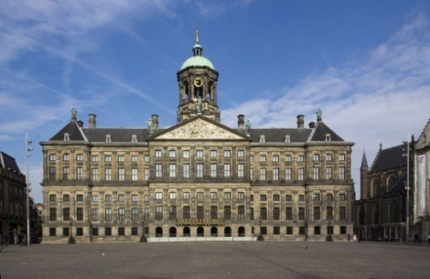](http://www.google.nl/url?sa=i&rct=j&q=paleis+op+de+dam&source=images&cd=&cad=rja&docid=zksE0-ztbGxLGM&tbnid=Y0fLv3sUO73pUM:&ved=0CAUQjRw&url=http://www.amsterdamsegrachtenhuizen.info/gracht/dm/dm02001/&ei=suLkUdTeI4fYPaudgZgO&bvm=bv.48705608,d.ZWU&psig=AFQjCNG9BsG4Xo7tmDczgYuoWt8LOh3I_w&ust=1374041080373501)