[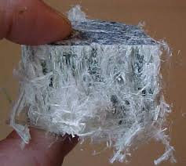](http://www.google.nl/url?sa=i&rct=j&q=&esrc=s&source=images&cd=&cad=rja&uact=8&docid=Py4Fv222nr_ImM&tbnid=uw0Q8W86lW5QqM:&ved=0CAUQjRw&url=http://www.givengain.com/cause/1056/images/&ei=pyD_U4rOAoey7AbghIHoAQ&bvm=bv.74035653,d.ZGU&psig=AFQjCNGMWTpvONjbokIhDGZlYbh_Lqy96g&ust=1409315335781503)

[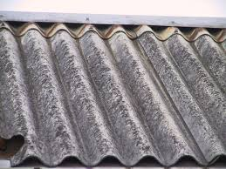](http://www.google.nl/url?sa=i&rct=j&q=&esrc=s&source=images&cd=&cad=rja&uact=8&docid=wtfxHkiFyXWzOM&tbnid=Ps7-0gSQXhSbmM:&ved=0CAUQjRw&url=http://blog.directwonen.nl/2014/01/29/Asbest+In+Uw+Woning+Wat+Moet+U+Doen.aspx&ei=1iD_U_TwMY2h7Aa824DICw&bvm=bv.74035653,d.ZGU&psig=AFQjCNGMWTpvONjbokIhDGZlYbh_Lqy96g&ust=1409315335781503)