[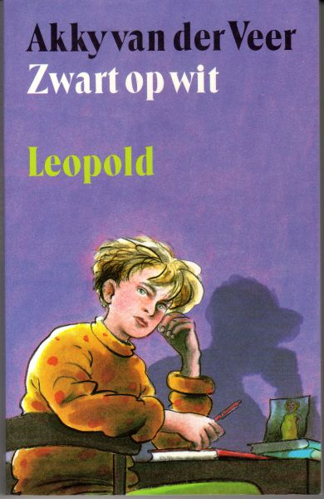](https://www.google.nl/url?sa=i&rct=j&q=&esrc=s&source=images&cd=&cad=rja&uact=8&ved=0ahUKEwifpr7qnJbOAhWJOhoKHfJPB9UQjRwIBw&url=https://www.boekwinkeltjes.nl/b/134557802/Zwart_op_wit_druk_1/&psig=AFQjCNGmtFflpF_DCUanceGSwKbu54fWww&ust=1469797585102894)

[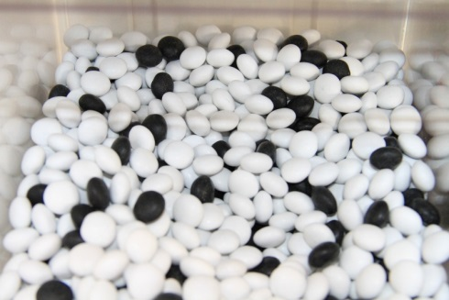](http://www.google.nl/url?sa=i&rct=j&q=&esrc=s&source=images&cd=&cad=rja&uact=8&ved=0ahUKEwiqz_jLnJbOAhXBWRoKHTDrAoAQjRwIBw&url=http://www.haagsch-snoephuis.nl/c-2278836-6/schepsnoep/&psig=AFQjCNF-ybCuZ8cow1AoSwDZlt9wNXealg&ust=1469797499168714)