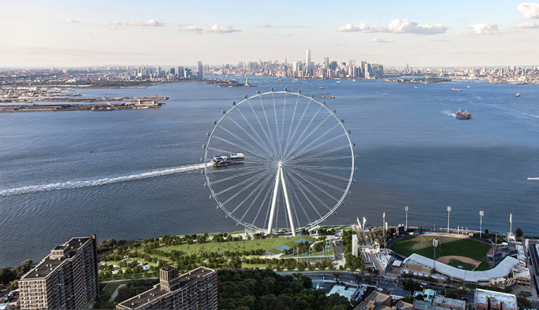

[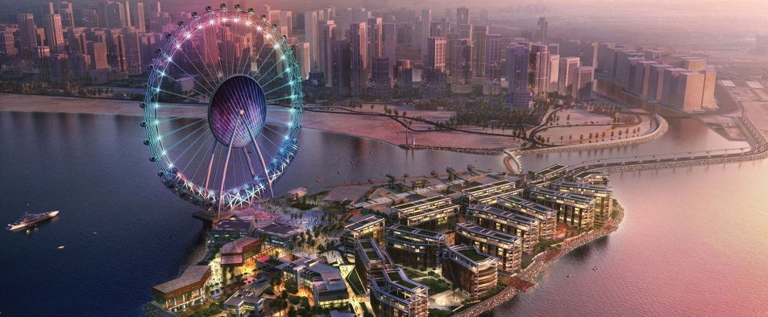](http://www.google.nl/url?sa=i&rct=j&q=&esrc=s&source=images&cd=&cad=rja&uact=8&ved=0ahUKEwiKwqSzzozPAhWG1xoKHeE0CfkQjRwIBw&url=http://www.allesoverdubai.info/dubai-bluewaters-island-grootste-reuzenrad-van-de-wereld/&psig=AFQjCNGe5i0UPWYPmsLDGN6PJ2dzG_ViKg&ust=1473864969710386)